BACTERIAL COMMUNITY STRUCTURE IN THE AMUNDSEN SEA POLYNYA, ANTARCTICA

by

SIERRA BARTLETT

(Under the Direction of Patricia Yager and Holly Bik)

ABSTRACT

In this study, we use 16 rRNA and taxonomic insights to understand that bacterial community in the Amundsen Sea Polynya, Antarctica. Polynyas are areas that are characterized by seasonal sea ice cover, massive algal blooms, and high productivity. One of the most productive polynyas is the Amundsen Sea Polynya (ASP) and Regional Ocean Models suggest the importance of an "iron conveyor belt,", including iron-rich deep water being upwelled through cavities of ice shelves, though this has yet to be empirically assessed from a microbial perspective. Along with this, the microbial ecology of a recent discovery of a coastal current (CC) (0-200m) that flows westward has yet to be explored. We found that communities were distinct based on water mass, as well as certain locations within the Amundsen Sea Polynya, including along the CC. Heterotrophic bacteria tend to dominate in the surface waters, near the bloom, while bottom water communities tend to vary based on location within the polynya, indicating unique biogeochemical niches in the deep water.

INDEX WORDS: Environmental microbiology, Antarctica, coastal polynyas,

microbial ecology, metagenomics

BACTERIAL COMMUNITY STRUCTURE IN THE AMUNDSEN SEA POLYNYA, ANTARCTICA

by

SIERRA BARTLETT

BS, Georgia Southern University, 2021

A Thesis Submitted to the Graduate Faculty of The University of Georgia in Partial Fulfillment of the Requirements for the Degree

MASTER OF SCIENCE

ATHENS, GEORGIA

2024

© 2024

Sierra Bartlett

All Rights Reserved

BACTERIAL COMMUNITY STRUCTURE IN THE AMUNDSEN SEA POLYNYA, ANTARCTICA

by

SIERRA BARTLETT

Major Professor: Patricia Yager

Committee: Holly Bik

Jaclyn Saunders

Electronic Version Approved:

Ron Walcott

Vice Provost for Graduate Education and Dean of the Graduate School

The University of Georgia

December 2024

DEDICATION

To Mary, who was my internship mom, good friend, and even better scientist.

ACKNOWLEDGEMENTS

I’d like to acknowledge the many members of the Bik lab for their help with the wet lab and statistics: Tiago for the major help with the wet lab and R code, Mirayana for the wet lab and organizational skills, and, Hunter and Alejandro for help with QIIME code.

TABLE OF CONTENTS

Page

ACKNOWLEDGEMENTS v

SECTIONS

1 INTRODUCTION 1

2 METHODS 7

3 RESULTS 10

4 DISCUSSION 13

APPENDICES

A SUPPLEMENTARY FIGURES 30

B SUPPLEMENTARY TABLES 36

REFERENCES 25

INTRODUCTION

When the Southern Hemisphere becomes exposed to more sunlight in the austral summer, massive packs of sea ice from the previous winter begin to melt (Thiele et al. 2022). In Antarctica, a known high-nutrient, low-chlorophyll (HNLC) zone is limited by both iron and light availability (Debeljak et al. 2023; Schine et al. 2021). The combination of open water and the immediate iron from the sea ice melt seeds phytoplankton blooms, primarily the haptophyte *Phaeocystis antarctica* (Ducklow et al. 2015; Richert et al. 2019; Wang et al. 2022)*.* The Southern Ocean is responsible for deep-water formation and 18% of global carbon absorption, storing and capturing atmospheric carbon dioxide (Williams et al. 2015). Most of this carbon processing comes from massive P. antarctica blooms and the bacteria accompanying them. In the entire Southern Ocean, coastal polynyas are responsible for the majority for the primary productivity and carbon uptake. A polynya is characterized as open water areas surrounded by sea ice, primarily caused by higher temperatures and catabatic winds, traveling from high to low pressure, pushing the sea ice out and away from the ice shelves (Richert et al. 2019; Choi et al. 2016; Dinniman et al. 2023). One of the most productive polynyas is the Amundsen Sea Polynya (ASP), at a maximum of about 2.5 gC/m per day (Yager 2021). *Phaeocystis* rapidly draws down carbon dioxide concentrations in these polynyas, supplying carbon and nutrients to the rest of the polynya and harboring a unique microbial heterotrophic community (Wang et al. 2022; Richert et al. 2019).

Many studies focus on the dynamics between bloom and bacterioplankton communities. However, few focus on other aspects that may influence the bacterial community and, in turn, nutrient overturning within the ASP. The surface communities are dominated by opportunistic heterotrophic bacteria equipped with the ability to degrade algal-derived organic matter (Teeling et al. 2012; Richert et al. 2019; Delmont et al. 2015). It is also known that there are distinct free-living and particle-associated communities, with the latter responsible for demineralizing algal material (Delmont et al. 2014, 2015). It is understood that the bloom drives bacteria in the surface communities, but little is known about bottom-water communities and how they might change in response to detritus, sediments, or other bacteria.

In the ASP, there are three distinct water masses: Antarctic Surface Water (AASW), Winter Water (WW), and Circumpolar Deep Water (CDW) (Richert et al. 2019). AASW is warmer, with fresher water from summer solar heating and increased sea ice and glacial melt. AASW is typically characterized by a subsurface temperature minimum, separated by the colder, fresher water below (Park, Charriaud, and Fieux 1998).The one below is WW, which is from winter sea ice production and convection, where strong winds cause evaporation and surface waters are overturned and sink while “warmer” waters rise to the surface (Kovalevsky, Bashmachnikov, and Alekseev 2020). CDW, warmer and saltier water sourced from the Antarctic Circumpolar Current off the continental shelf, is at the very bottom. This water is a significant source of dissolved iron (dFe) to the polynya, accounting for 32% of the total dFe supply in the Amundsen Sea (Dinniman et al. 2023). The CDW is likely supplemented by mixing with high dFe shelf waters, where sediment dissolution and increased remineralization occur (Dinniman et al. 2023, 2020; St-Laurent et al. 2017). CDW is upwelled toward the surface by bathymetric features and eddies, which allow microbial communities to access the highest dFe concentrations in the region (Smith et al. 2021). Another way CDW is supplied to the ASP is through the “meltwater pump.” A study by St-Laurent et al. (2017) highlighted the critical role of ice shelf melt-driven circulations (the “meltwater pump”) in transporting sediment-derived dissolved iron (dFe) to the upper 300 m of the water column. Following the bathymetry, the CDW eventually reaches underneath ice shelves, mainly the Getz Ice Shelf (GIS) and Dotson Ice Shelf (DIS) in the ASP. Then, the CDW begins to melt the underside of the shelf, which makes the water more buoyant and the outflow is provided back to the polynya (Randall-Goodwin et al. 2015). Dinniman et al. found that sediment accounted for 39% of the total dFe supply, 75% of which is first advected into the ice-shelf cavity before delivery to the surface waters (2023). Glacial meltwater sources discharge nutrients, metals, particles, and freshwater microorganisms into the open water, and there are few to no studies looking at how this affects the microbial community at Dotson and in turn, nutrient cycling and the rest of the food web (Alcamán-Arias et al. 2021). Additionally, Regional Ocean Models suggest how bacteria may alter CDW before it travels into the cavities of the ice shelves is not well understood (St- Laurent et al. 2017).

These polynyas, especially the ASP, are of interest to study climate-sensitive areas, as temperatures continue to rise and ice shelves continue to melt at an increasing rate. With an increase of glacial melt, it can prevent deep water formation, which as unforeseen consequences for global overturning circulation (Silvano et al. 2018). It is important to study the effects of freshwater input on not only the physical properties of the ASP, but on how it may also affect primary production, and in turn the bacterial community that accompanies it. This study is a multidisciplinary effort, part of ARTEMIS, to understand the fluxes and microorganisms from the ice shelf outflow, how iron and carbon compounds

**The main questions of this study are:**

1. How do bacteria communities (both free-living and particle-associated) change based on location within the ASP?
2. Do bacteria contribute to or come out of the Dotson outflow?
3. How do high and low iron communities differ? Are there any specific indicator taxa?
4. How do CDW communities change as they come onto the shelf and circulate in the rest of the polynya?

METHODS

**Sample collection**

Samples were collected on the R/V NB Palmer expedition, ARTEMIS (January–Feburary 2022) in the Amundsen Sea, Antarctica (Figure 1). Sampling was carried out with 12 L Niskin bottles mounted on an SBE 911; Sea-Bird Electronics) equipped with CTD (conductivity-temperature-depth) and oxygen sensors. Seawater samples were collected at varying depths, including surface and bottom waters. Intermediate samples vary, but most were taken at the mixed layer, temperature minimum (T-min), and an in-between sample. Individual depths varied per station and time according to the different depth thresholds, attempting to sample the three prevalent water masses (AASW, WW, CDW). Per sampling event, 8–12 L of seawater were filtered first onto a 2-3μm polycarbonate pre-filter, then equally diverged through replicate .2 μm durapore filters (Millipore, Burlington, MA). Filters were stored in cryovials at -80C. Samples were extracted from each filter using the Zymo Research Quick-DNA Fecal/Soil Midiprep Kit according to the manufacturer's instructions (NA. cat 11-322MD). DOC contents were analyzed in Medeiros lab (University of Georgia). Dissolved iron data was provided by the Sherell lab (Rutgers University). Nutrient data, including nitrite, nitrate, ammonia, silicate, and phosphate, were collected by an autoanalyzer on board the R/V NB Palmer was included in the analysis.

**Sample preparation**

PCRs were set up in a dedicated laminar-flow hood that underwent daily bleach and UV light sterilization. The V3–V4 region of 16S rRNA genes were amplified using primers 515F (GTGYCAGCMGCCGCGGTAA) and 806R (GGACTACNVGGGTWTCTAAT). Sequencing was performed on a MiSeq platform (Illumina, San Diego, CA) using 2 × 300 bp paired-end libraries according to the "16S Metagenomic Sequencing Library Preparation protocol" (Illumina). Both positive (ZymoBIOMICS™ Microbial Community Standard (Zymo Research, Irvine, CA)) and negative controls (molecular-grade water) were included in all PCRs. The following PCR profile was used for amplification of 16S rRNA gene fragments: 94°C for 3 min; 94°C for 45 s, 50°C for 60 s and 72°C for 90 s for 35 cycles; and 72°C for 10 min. PCR amplification success was evaluated with gel electrophoresis (agar 1%). Purification of PCR products was subsequently carried out using a magnetic bead purification protocol using Agencourt AMPure XP beads (Beckman Coulter, CA, USA) and following the manufacturer's protocol.

**Data analysis**

Reads were processed into amplicon sequence variants (ASVs) using QIIME2 and the SILVA v138 database. Before analysis, the R package decontam was used to remove potential contaminants, using the prevalence and frequency method based on the controls. Communities were separated into “free-living” and “particle-associated”; The latter for bacteria on the 2-3 µm pre-filter, and the former that was caught on the 0.2 µm filters. based on what was caught on, >0.2 µm Analysis and plotting were performed in RStudio, primarily using the phyloseq, vegan, ggplot2, qiime2R, ggplot2, indicspecies, ANCOMBC and ComplexHeatmap packages. Ordination figures were generated with the plot_ordination function within phyloseq. The **distance** function was used to calculate beta-diversity (Bray-Curtis), the **adonis** function to perform an ANOVA, the **TukeyHSD** for Tukey test, and the **multiplatt** function for indicator species analysis. The workflow figure (**Figure 1**) has been created with Biorender.com. The ASV table and corresponding sequences were run through the PICRUSt2 pipeline for functional genomic prediction, filtered based on desired KO (Kegg Orthology), and then imported into R. The bioinformatics workflow, including QIIME2 and PICRUSt2 pipeline, is available at https://github.com/sierra-uga/ARTEMIS-MS.

We used the R package oce for water mass categorization and can be found in **Table 1**. We excluded the continental shelf station, STN 198, in many of the microbial community analyses within the ASP, due to the distinctly different community, altering the ordination and Bray-Curtis analyses. Based on velocity profiles provided by the ARTEMIS cruise, samples were denoted “outflow” if the conservative velocity (m/s) was above ~0.1, heading northward. Inflow stations were samples closest to the DIS, with the conservative velocity below ~0.1, heading southward (**Table 2**). For categorizing iron (dFe) levels , used in **Figure 8**, anything above or equal to 0.5 nmol/kg dFe was considered “High” and anything below 0.5 nmol/kg was considered “Low”.

RESULTS

The CCA of the communities show that the particle-associated is more related by the area within the polynya, while the surface communities are driven by bloom, as suggested in the typical communities found there. *Polaribacter* is a known algal-associated bacteria in high-latitude regions (pole-to-pole paper). Previous studies say that the bottom-water communities are heavily influenced by the surface communities, which are driven by the bloom. Our findings suggest that certain areas are in-fact driven by the bloom, like near the Dotson and Getz, but distinct communities in open polynya stations, especially in the free-living. The CDW communities are distinctly different based on the area in the polynya, suggesting that the presence of CDW is likely another factor driving the microbial community. *Pseudoalteromonas,* of the *Pseudomonadaceae* familyis only majorly present in STN2 and STN4, both stations that follow the Dotson Trough, were pure CDW has yet to be altered by meltwater and is likely not strictly influenced by bloom. Bloom markers near the Dotson are dominated by heterotrophic bacteria, mainly *Polaribacter spp., Nitrocolacae.* STN89, an eastern notch station is distinctly different than bloom-marker communities, where the bloom was almost non-existent. The unique community underneath the bloom, found in Richert et al., mostly consists of opportunistic heterotrophic bacteria, like SUP05 clade, of the Thioglobacae family, or SAR 11 clade, known organoheterotrophs, capable of diverse genomic abilities due to their small genomes and horizontal transfer. When comparing the communities together, Dotson-OP was significantly different in certain areas, particular stations, like STN 174, are different in each water mass, dominated by Saprinerceae, a known particle-associated taxa. The free-living and particle-associated communities don’t appear to be influenced by the location in the polynya, more so the position in the water column in the mesopelagic, that includes both AASW and WW, where there are distinct nutrient and diversity shifts. The CDW, and only a few WW samples have *Pseudomonas*, a genomically diverse organism, a known pathogen or psychrophilic organism.   
 The community not only shifts because of the bloom, but also by DOC, potentially linked to the bloom, but also potentially by sloppy feeding, especially at stations like STN174, where the iron, cobalt, and magnesium are high at the bottom, and DOC is essentially depleted. In the surface waters, DOC follows the same gradient as temperature and oxygen, where sloppy feeding may play considerable role in the remineralization of organic matter, because of the microbial loop.

Though the inflow and outflow aren’t inherently different, the outflow might influence the communities by supplying more iron to the bloom, via the cavity at about ~400m at the ice shelf face. A Tukey test showed that both free-living and particle-associated communities were not different (F= , p < 0.5), and this could be because there isn’t enough time within the cavity for significant community changes, and instead the outflow more influences the communities that are following the coastal current in the surface, shown by the CCA, where western CC is distinctly different from the Dotson stations, including the outflow. Western CC and Dotson bottom-water stations do not include pure CDW, as it was likely categorized as WW-CDW, with the fresh meltwater addition, making it mCDW.

As previous studies, like Richert et al. suggest, the surface waters are dominated by opportunistic heterotrophic taxa, and leads to a less diverse community in the surface waters. Many of the previous bacterial studies in the ASP do not incorporate the inflow and outflow, and how the deep CDW travels into the ASP vis bathymetry.  
  
**Inventories**

In total, there were 21 stations from the ARTEMIS cruise that had samples taken for DNA extraction. These samples were within large environmental ranges in temperature (-1.8 to 1.1 °C), salinity (33.49 – 34.70), and depth (2 – 1271 m; **Table S1; Figure S1**). Other nutrients (**Table S1**) included nitrite (0–0.08 µmol/L); nitrate (9.22–38.6 µmol/L); phosphate (0.87–2.74 µmol/L); ammonia (0.03–0.65 µmol/L); and dissolved organic carbon (34.6–77.6). The specific nutrients for stations used in analyses can be found in **Table S2**. Environmental parameters were visualized in **Figure S5** and **Figure S6**. Without considering bacterial community structure. In the upper 200m, environmental conditions follow water masses, while location in the polynya doesn’t seem to play a role in ordination. Waters below 200m show a distinct separation in both location (**Figure S5**) and water mass (**Figure S6**).

**Overall trends**

We found that both free-living and particle associated communities were both statistically significant, both >200 and <200m, based on the location within the polynya (p < 0.001). When running a Tukey test, only the Dotson-OP category was significant in the upper 200m free-living communities.

* **CCA/PCA/rel abund**
* **PICrust**
* **Indicator species**

**CDW waterfall / deep water**

* **CCA/PCA/rel abund**

**Inflow/Outflow**

* **Adonis / Tukey for free + particle**
* **Indicator species**
* **ANCOM-BC**

**Testing iron conveyer belt**

* **High/low iron,**
* **CDW waterfall**

**Discussion**

* **Why is iron at the bottom? Look at paper in paperpile**
  + **Salty tolerant bacteria in bottom waters, at ice shelves, pseudomonas dominates, while in open polynya,**
  + **A significant depression on the continental shelf, such as a glacial trough, may allow a thicker, undiluted layer of CDW onto the continental shelf.**
  + **Outlet glaciers in the Amundsen Sea Embayment have accelerated[4-6], receded[7] and thinned in recent years, which has largely been attributed to increased melting of their ice shelves by Circumpolar Deep Water[8, 9]. This has resulted in grounding line recession[7], which may result in marine ice sheet instability in West Antarctica**
    - **Rignot, E., et al., Widespread, rapid grounding line retreat of Pine Island, Thwaites, Smith, and Kohler glaciers, West Antarctica, from 1992 to 2011. Geophysical Research Letters, 2014: p. n/a-n/a. Steig, E.J., et al., Tropical forcing of Circumpolar Deep Water Inflow and outlet glacier thinning in the Amundsen Sea Embayment, West Antarctica. Annals of Glaciology, 2012. 53(60): p. 19-28. Shepherd, A., D. Wingham, and E. Rignot, Warm ocean is eroding West Antarctic Ice Sheet. Geophysical Research Letters, 2004. 31(23): p. L23402.**
  + **From rob: If you have more bugs that are Fe oxidizers where dFe is high, this might point to near-bottom communities where we hypothesize Fe(II) is fluxing of sediments. My most recent cruise to the Amundsen (GP17-ANT) found generally higher Fe(II) in surface and near-bottom, compared to mid-depths. Seeing your note below, perhaps Ilumato is taking advantage of the near-bottom source, though Fe(II) will Oxidize within an hour or two inorganically, no bacteria needed.**
  + **Figure 6 🡪 flavo are lost in outflow, heterotrophic bacteria lost**
* **General previous trends found**
  + **Free vs particle associated**
  + **What confirms it?**
  + **Surface community similar**
  + **Delmont, Richert**
* **Glacial melt, deep sea, and sea ice bugs**
  + **Pseudomonas**
* **Potential iron related taxa found**
* **Open polynya stations /CDW waterfall stations**
* **Thwaites/pine island glacier, highest rate basal melt, providing freshwater input, for sea ice formation, sea ice forms, brine rejection, sinks to bottom. Ww is from previous winter**
* **Limitations**
  + **DNA, uncultured/unidentified bacteria because of remote location.**
  + **Lack of biological replicates for particle associated.** 
    - **Almost all biological replicates for free-living**

**To do**

Add ARTEMIS explanation to intro, line up to ARTEMIS GOALS

Add tables to methods (water mass)

DISCUSSION

Along the ice shelf, a previously overlooked dynamic delivers nutrients to the polynya. Due to the easterly winds, a coastal current run along the ice shelves in the upper 200 meters, approximately the thickness of the ice shelf itself. This coastal current comes from the Pine Island Glacier in the east, near Twaites, the fastest melting glacier in Antarctica, and travels along the DIS toward GIS in the west. The coastal current not only brings iron (from the abundance of sea ice in the eastern notch) but also could aid in bringing the outflow from the DIS (iron-rich water) to the polynya.

Several iron-related taxa (*Alteromonadales, Oceanospirillales,* and *Rhodobacterales*) are present in surface and bottom water samples. The main bacterial contributors are different, indicating a unique biogeochemical role. Bottom water from both free-living and particle-associated samples exhibits a more diverse bacterial community. Though our results do not show a significant difference in surface and bottom water, this could be due to myriad factors, including the location within the polynya, pre-bloom dynamics (no detritus to breakdown), insufficient samples, etc. Our hypothesis is partially confirmed by the Tukey tests. The next step will be to do the same analysis for archaea because they are known to be extremophiles and are also incredibly important to the biogeochemistry of marine ecosystems. Previous studies have shown they have an untapped importance to the Southern Ocean and often get overlooked in microbial community analysis. Overall, this project shows a clear distinction between open polynya and ice shelf, indicating an unexplored importance for the proposed coastal current and the biogeochemical implications.

Most of the glacial meltwater released by these ice shelves is transported westward in the coastal current to the Amundsen Polynya in the top 300 to 400 m of the water column (11). [Meltwater exits the cavity beneath the Dotson Ice Shelf south of the polynya (fig. S2A), but the core of this outflow is located on the western edge of the polynya (12) and therefore likely has less impact on convection in the Amundsen Polynya.) <https://www.science.org/doi/10.1126/sciadv.aap9467>

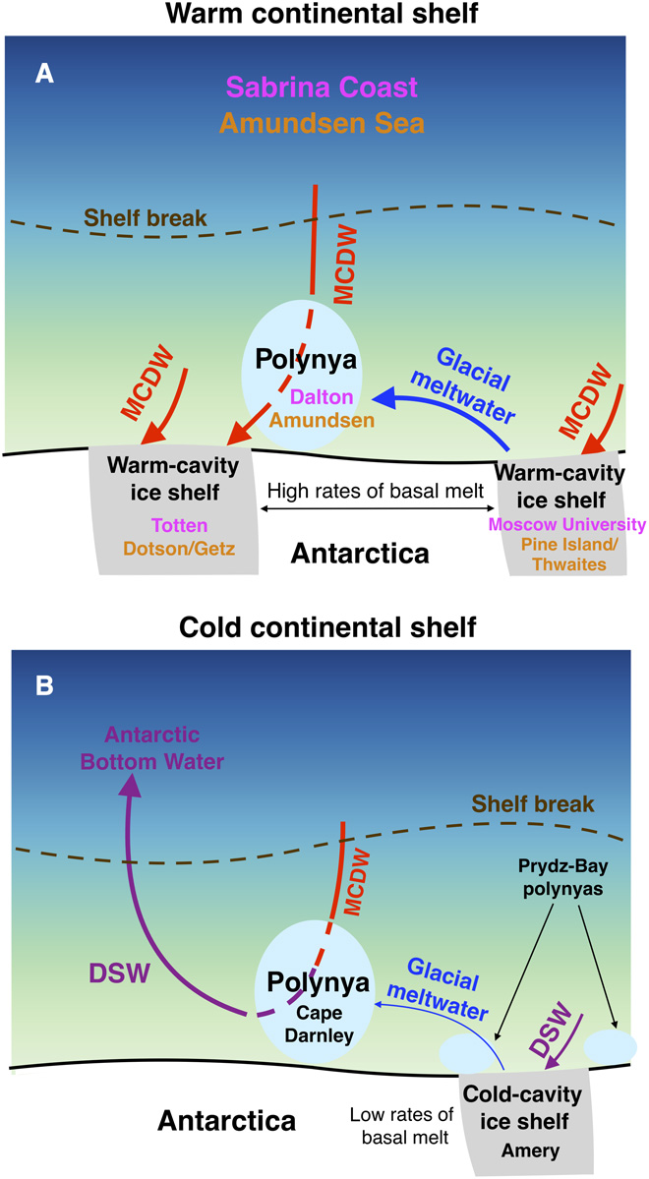

FIGURES

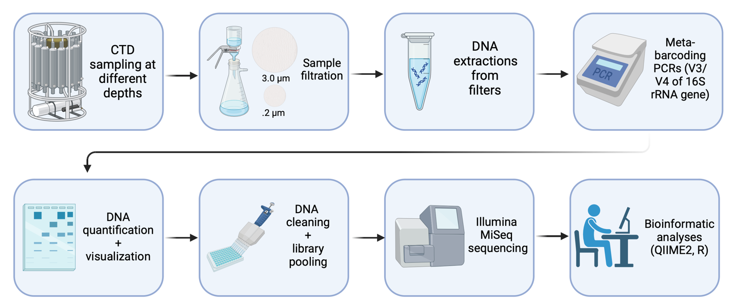

**Figure 1.** Pipeline of study.

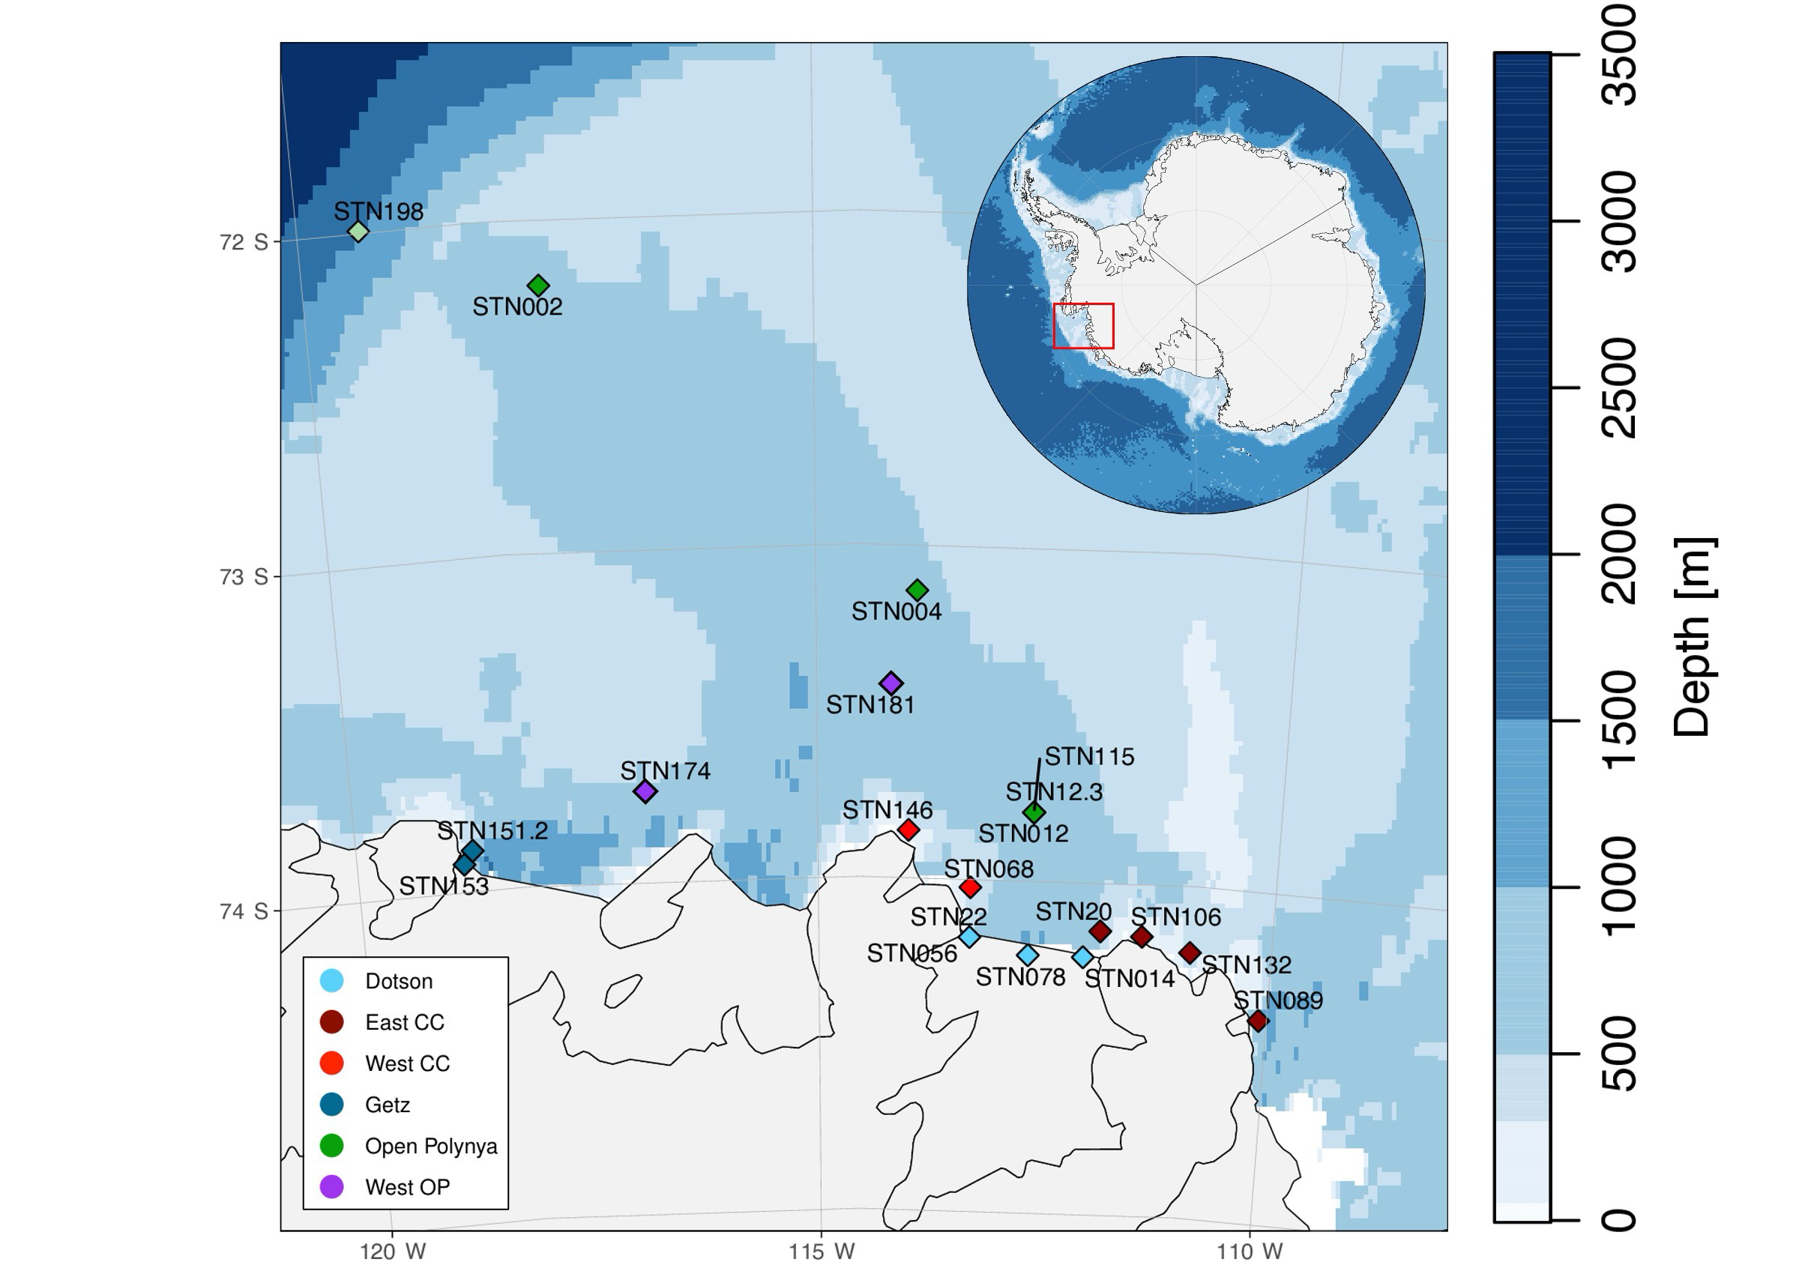

**Figure 2.** Station map with bathymetry. Colors are coordinated with location.

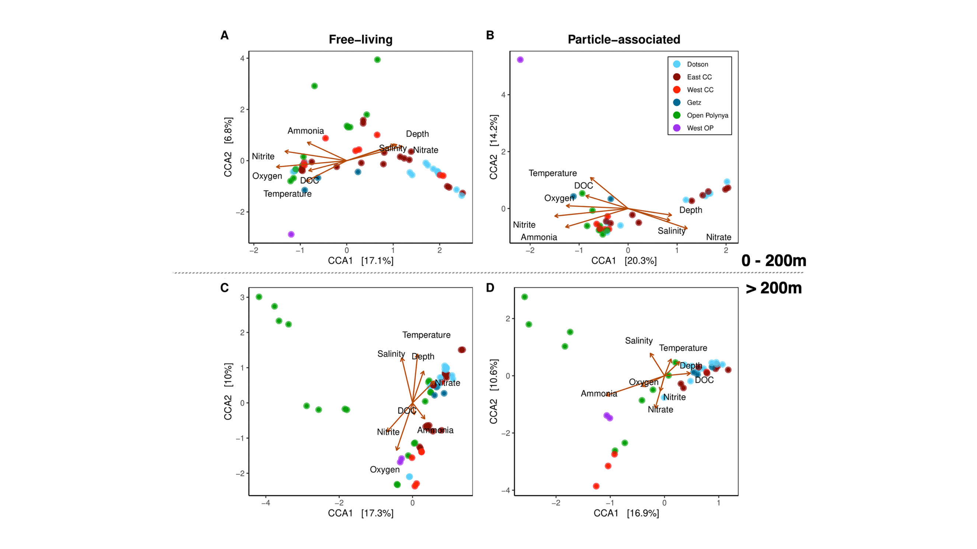

**Figure 3.** Canonical Correspondence Analysis (CCA) of free-living (**A, C**) and particle-associated (**B, D**) bacterial communities based on **location** within the ASP. First row CCAs are surface-200m and bottom row CCAs are 200m-bottom.

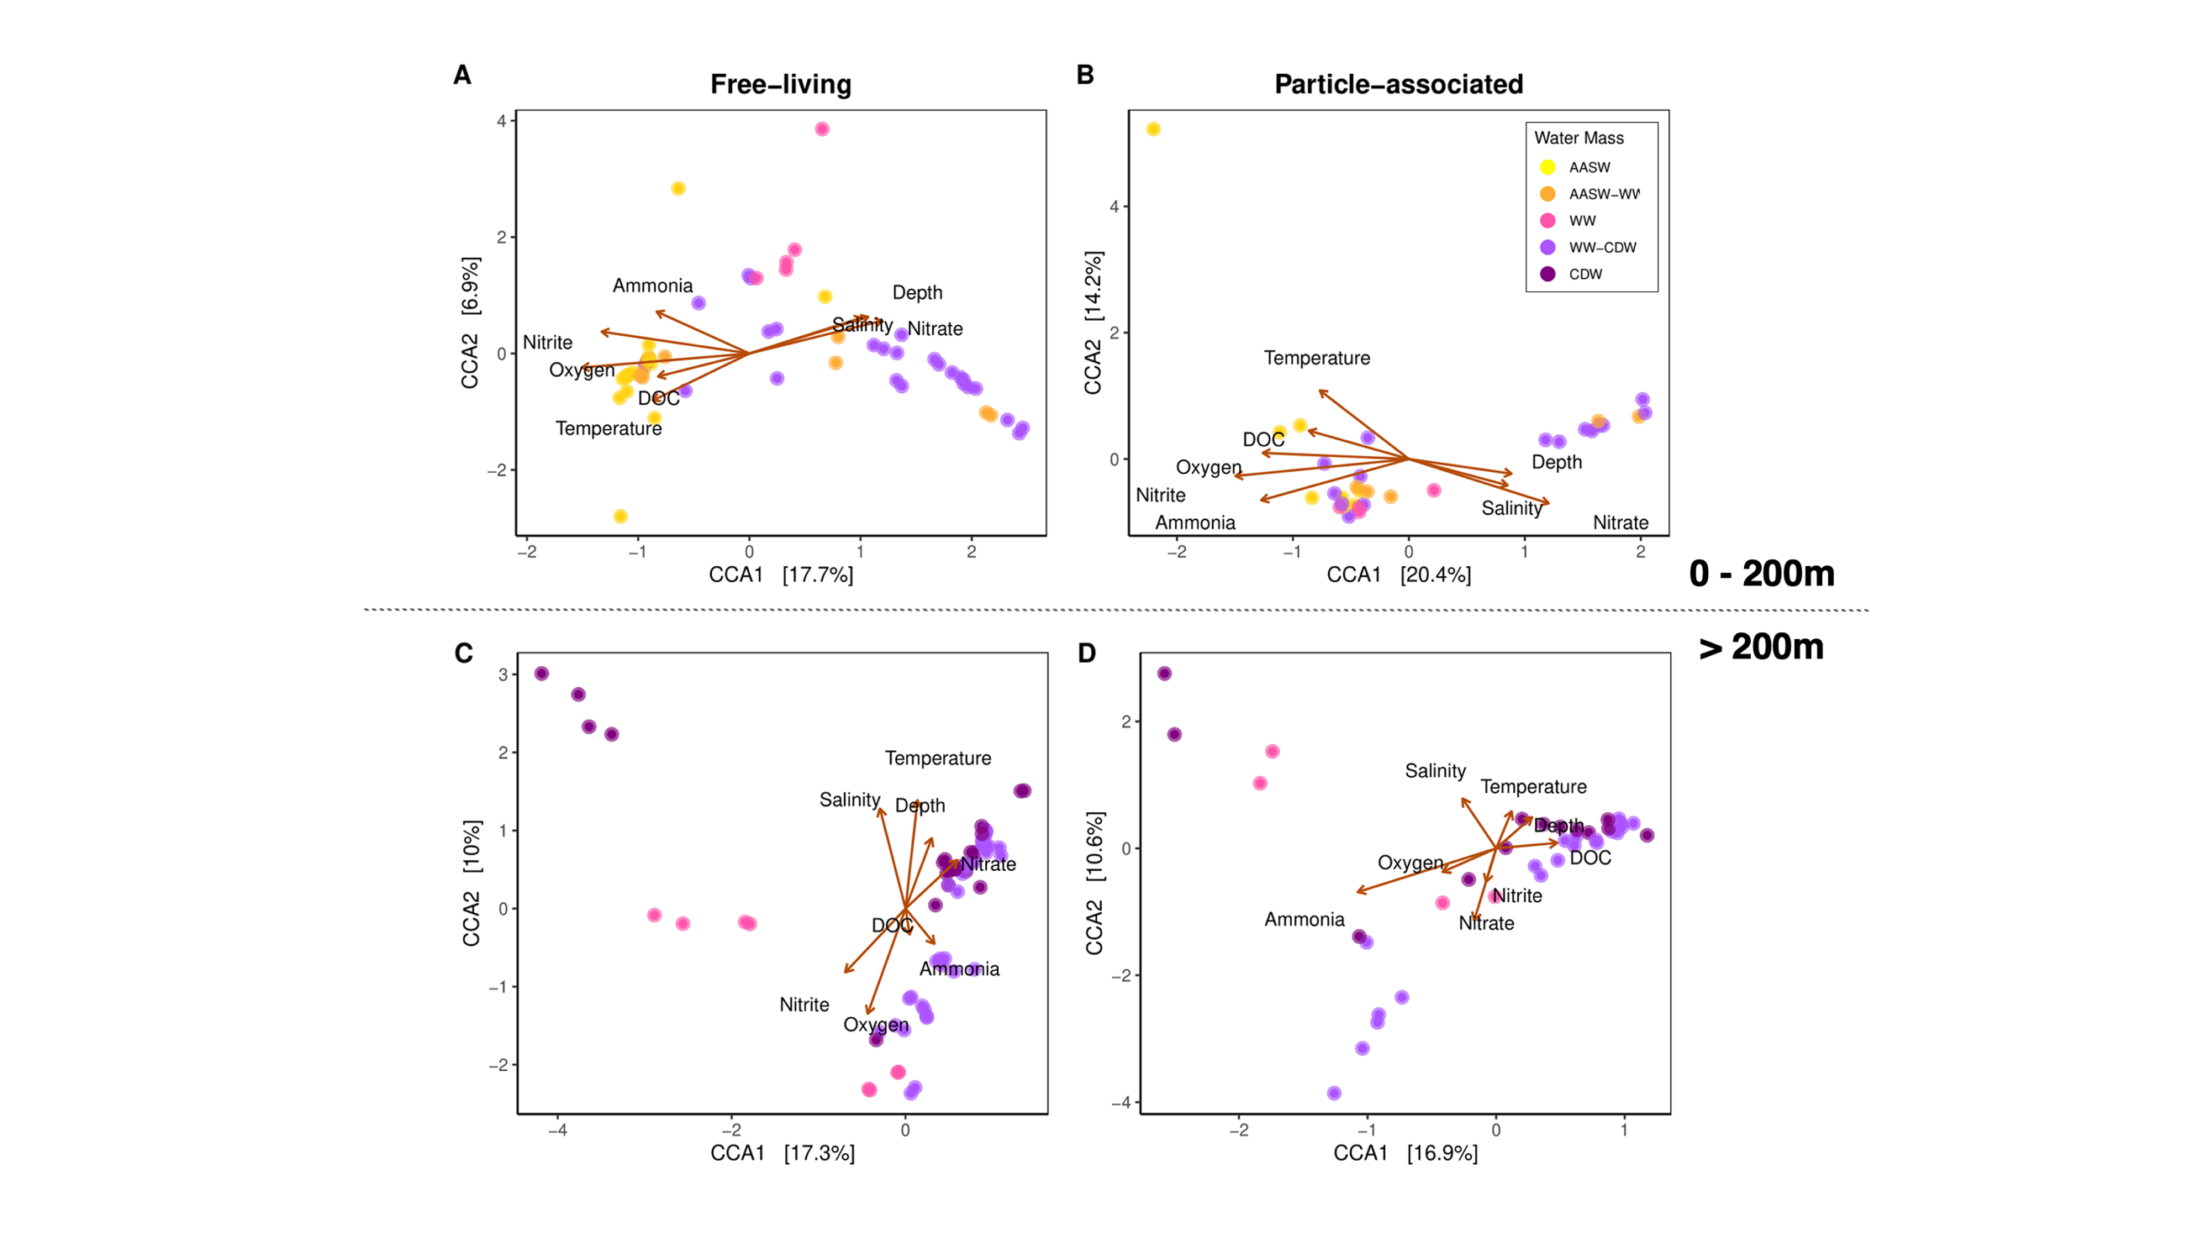

**Figure 4**. Canonical Correspondence Analysis (CCA) of free-living (**A, C**) and particle-associated (**B, D**) bacterial communities based on defined **water mass**. First row CCAs are surface-200m and bottom row CCAs are 200m-bottom.

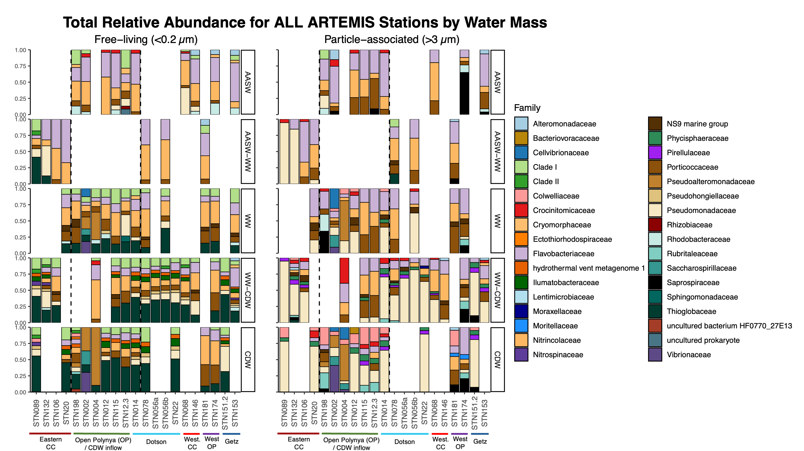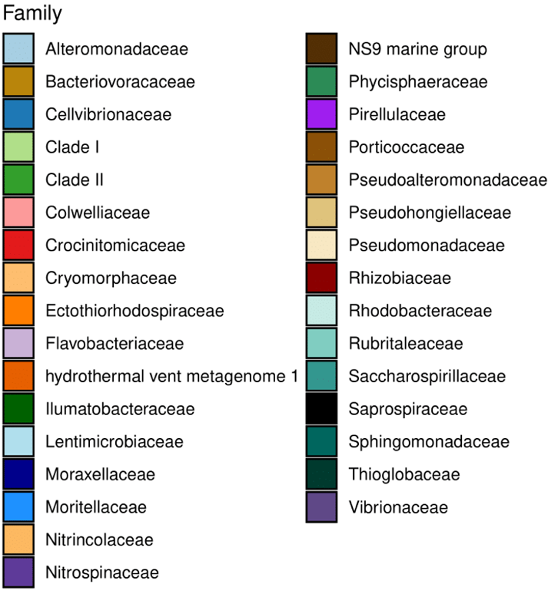

**Figure 5a.** Relative abundance for free-living (left) and particle-associated (right) communities at the family level. Each row represents a water mass, labeled on the right.

**Figure 5b.** Legend for the Family-level taxa that corresponds with Figure 5a.

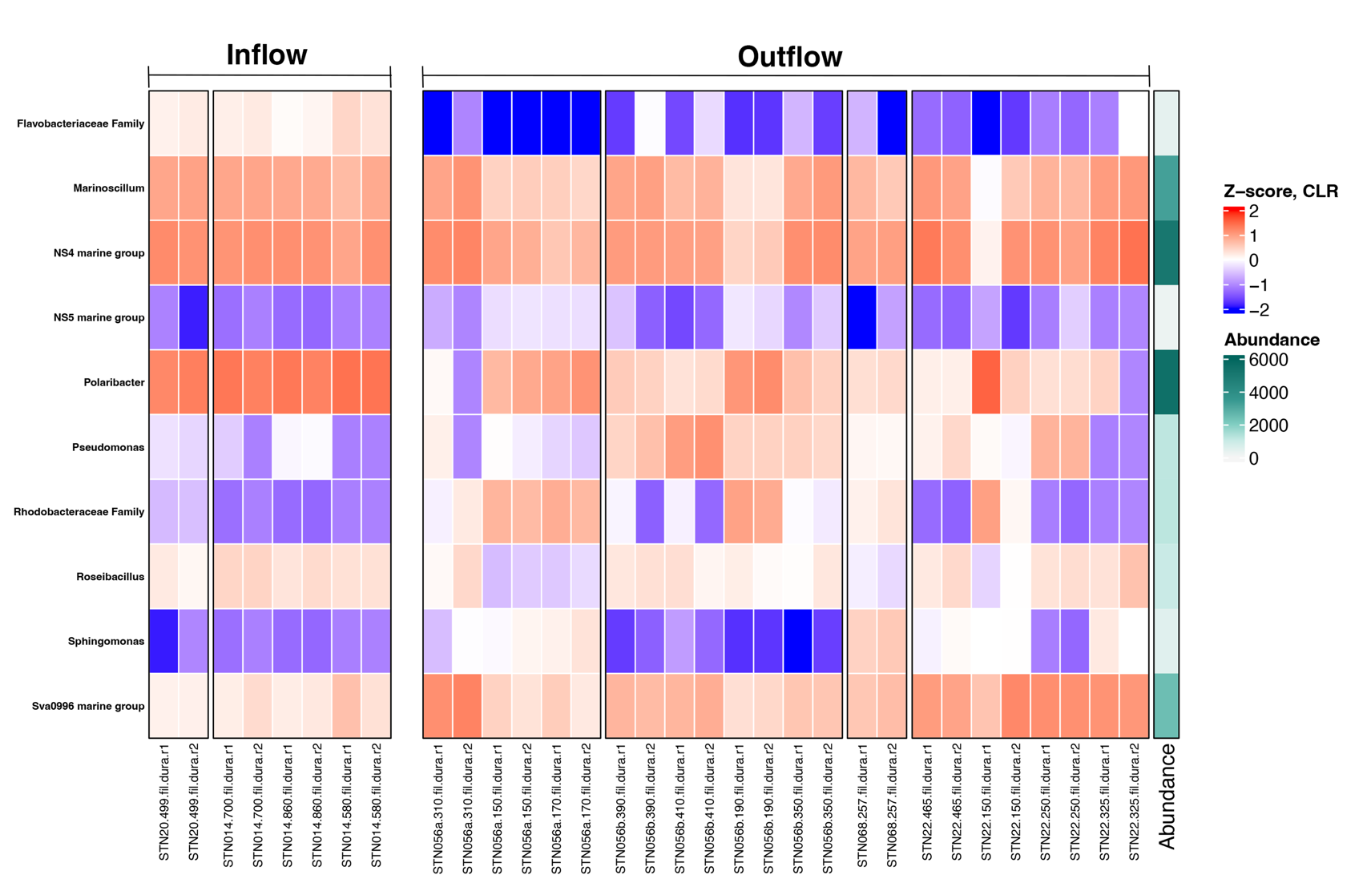

**Figure 6.** Significant **free-living** taxa from ANCOM-BC analysis for inflow vs. outflow samples. Z-score derived from log-transformed data. No significant change in particle-associated taxa from ANCOM-BC analysis.

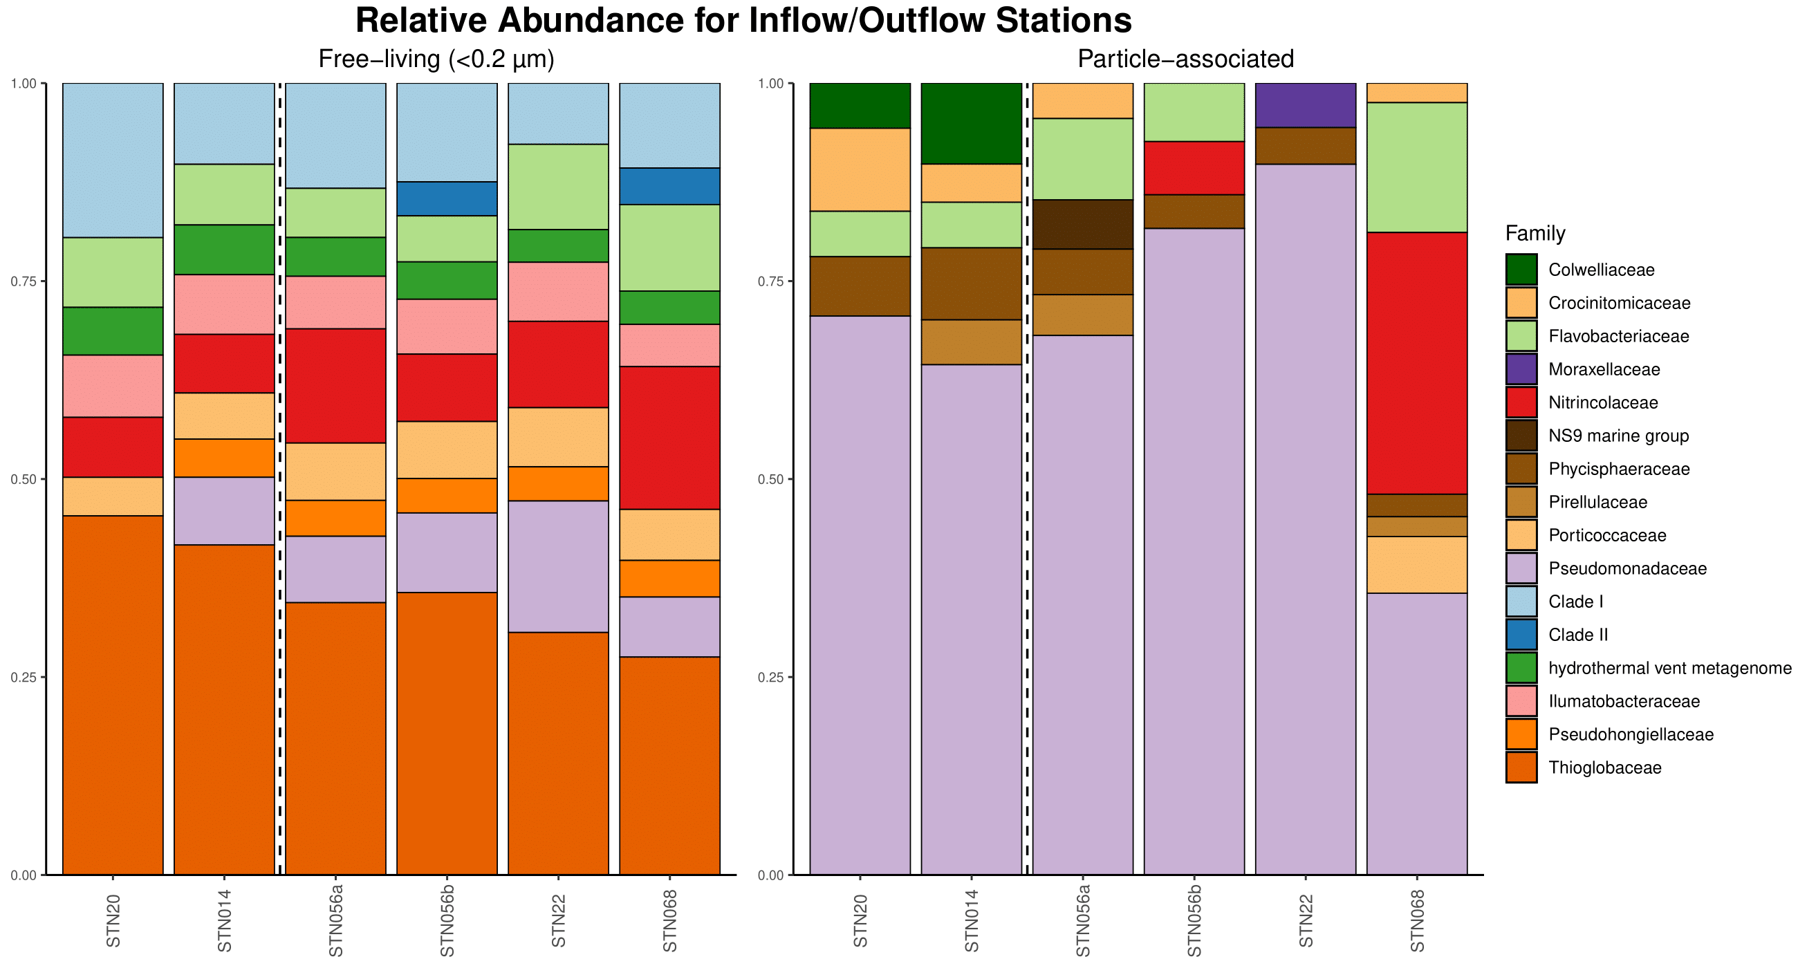

**Figure 7.** Relative abundance for free-living (left) and particle-associated (right) communities at the family level. In each community, inflow stations are before the black dashed line, while outflow are after.

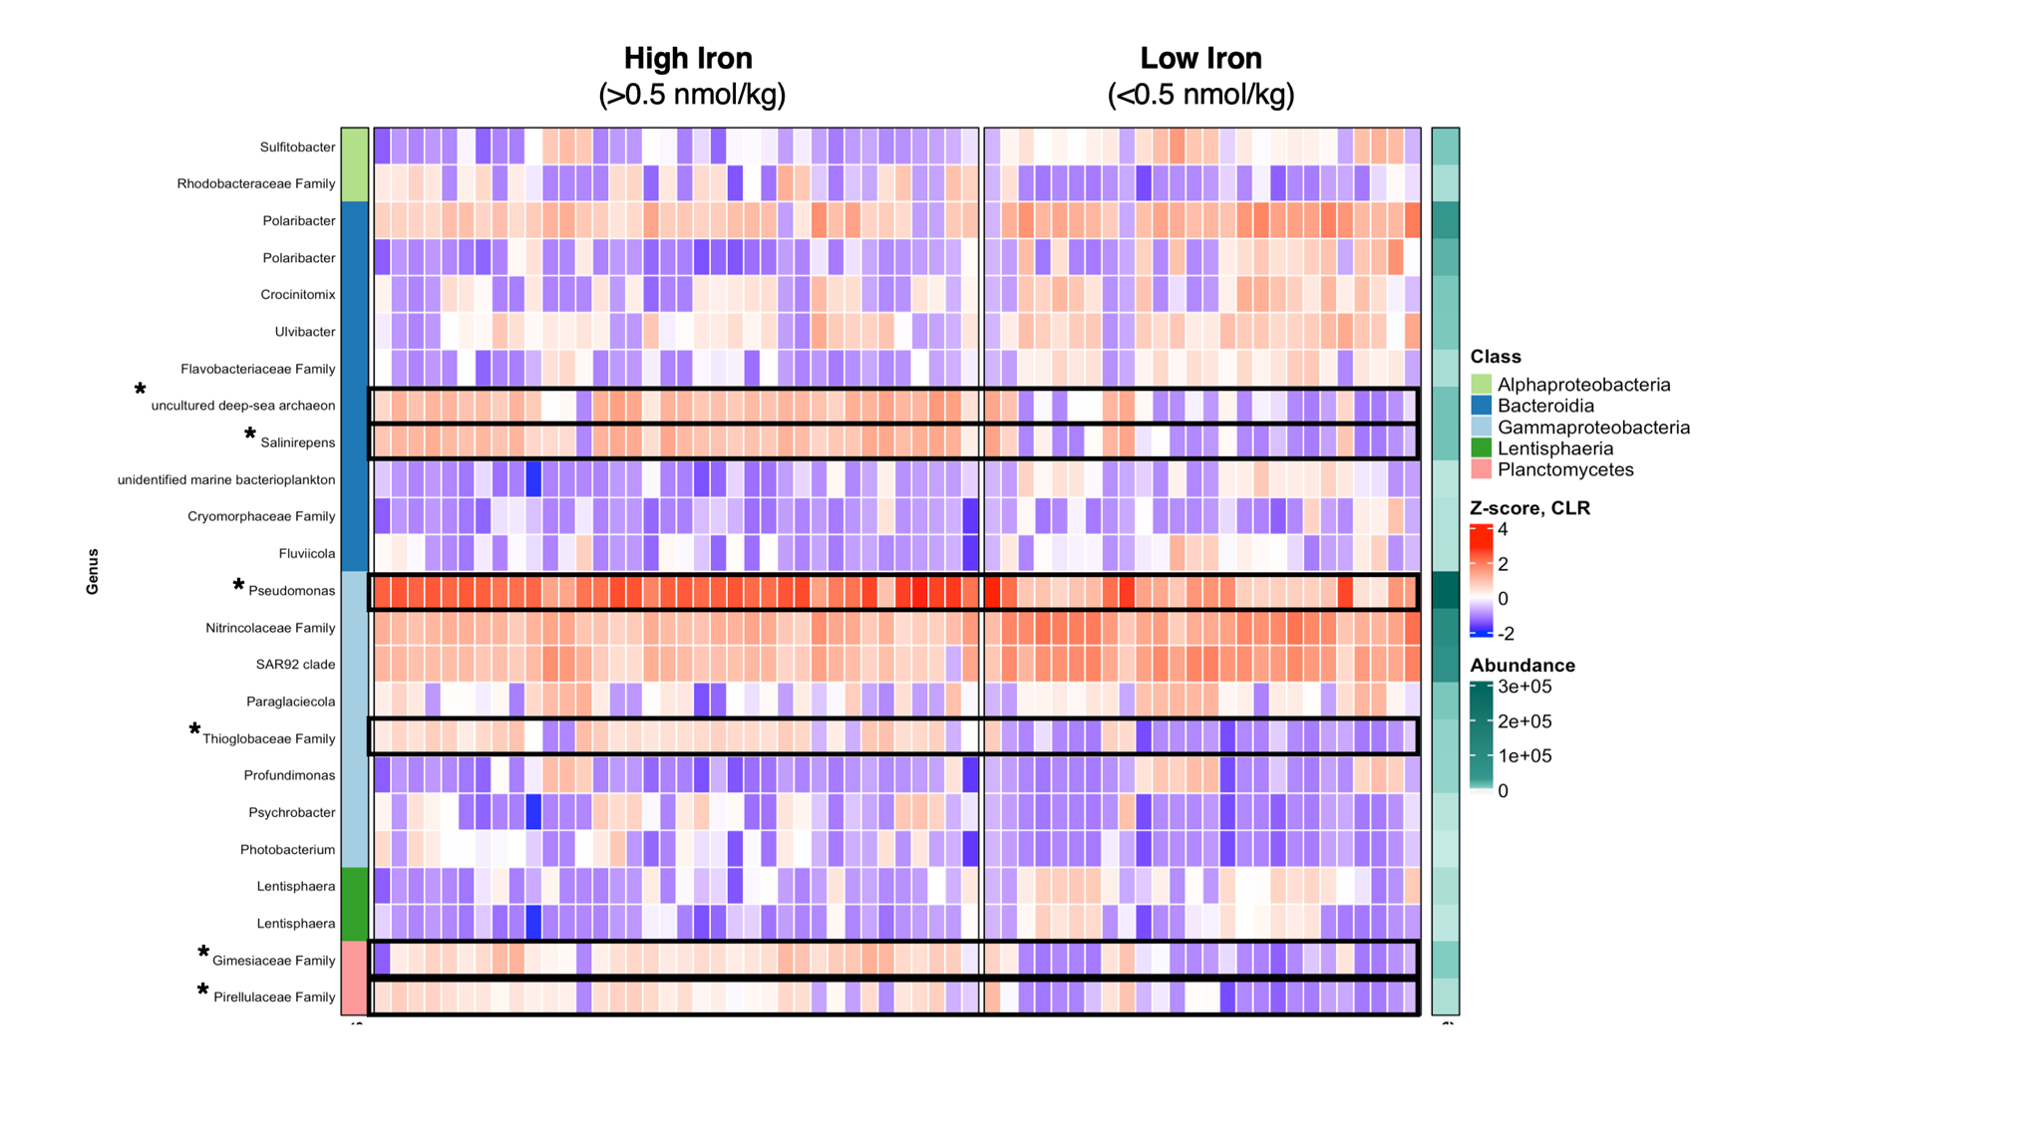

**Figure 8**. Significant **particle-associated** taxa from ANCOM-BC analysis for high (>0.5 nmol/kg) or low (<0.5 nmol/kg) dFe concentrations. Z-score derived from log-transformed data. See Supplementary Information for significant free-living taxa.

TABLES

**Table 1.** Water mass characterization with temperature and salinity ranges.

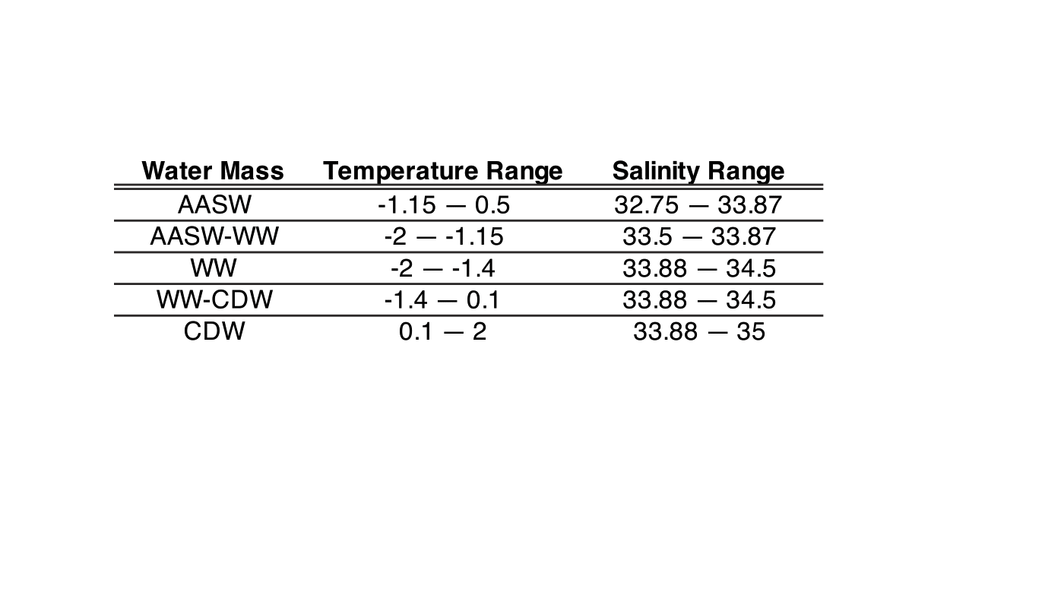

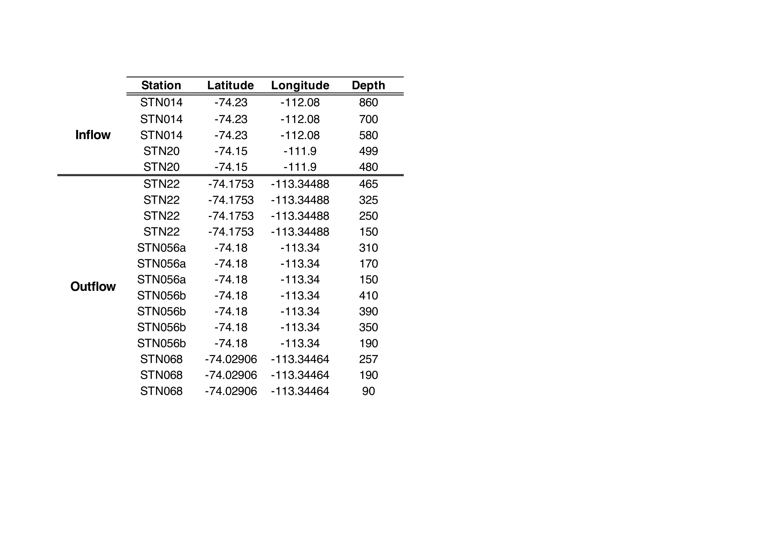

**Table 2**. Inflow and outflow stations and depth.

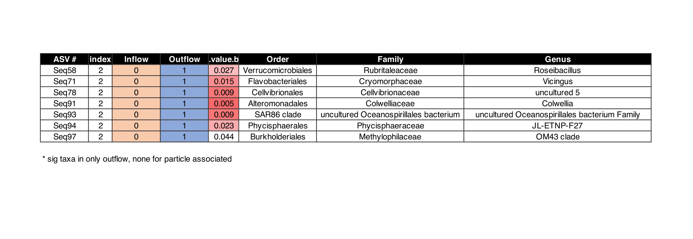

**Table 3.** Indicator species analysis of significant taxa in **free-living** outflow community. No significant indicator taxa appeared for particle-associated community.

REFERENCES

Alcamán-Arias, María Estrella, Sebastián Fuentes-Alburquenque, Pablo Vergara-Barros, Jerónimo Cifuentes-Anticevic, Josefa Verdugo, Martin Polz, Laura Farías, Carlos Pedrós-Alió, and Beatriz Díez. 2021. “Coastal Bacterial Community Response to Glacier Melting in the Western Antarctic Peninsula.” *Microorganisms* 9 (1): 1–18.

Choi, Seon-Bin, Jong-Geol Kim, Man-Young Jung, So-Jeong Kim, Ui-Gi Min, Ok-Ja Si, Soo-Je Park, et al. 2016. “Cultivation and Biochemical Characterization of Heterotrophic Bacteria Associated with Phytoplankton Bloom in the Amundsen Sea Polynya, Antarctica.” *Deep-Sea Research. Part II, Topical Studies in Oceanography* 123 (January): 126–34.

Debeljak, Pavla, Barbara Bayer, Ying Sun, Gerhard J. Herndl, and Ingrid Obernosterer. 2023. “Seasonal Patterns in Microbial Carbon and Iron Transporter Expression in the Southern Ocean.” *Microbiome* 11 (1): 187.

Delmont, Tom O., A. Murat Eren, Joseph H. Vineis, and Anton F. Post. 2015. “Genome Reconstructions Indicate the Partitioning of Ecological Functions inside a Phytoplankton Bloom in the Amundsen Sea, Antarctica.” *Frontiers in Microbiology* 6: 1090.

Delmont, Tom O., Katherine M. Hammar, Hugh W. Ducklow, Patricia L. Yager, and Anton F. Post. 2014. “Phaeocystis Antarctica Blooms Strongly Influence Bacterial Community Structures in the Amundsen Sea Polynya.” *Frontiers in Microbiology* 5 (DEC). https://doi.org/10.3389/fmicb.2014.00646.

Dinniman, Michael S., Pierre St-Laurent, Kevin R. Arrigo, Eileen E. Hofmann, and Gert L. van Dijken. 2020. “Analysis of Iron Sources in Antarctic Continental Shelf Waters.” *Journal of Geophysical Research, C: Oceans* 125 (5). https://doi.org/10.1029/2019JC015736.

———. 2023. “Sensitivity of the Relationship between Antarctic Ice Shelves and Iron Supply to Projected Changes in the Atmospheric Forcing.” *Journal of Geophysical Research, C: Oceans* 128 (2). https://doi.org/10.1029/2022jc019210.

Ducklow, Hugh W., Stephanie E. Wilson, Anton F. Post, Sharon E. Stammerjohn, Matthew Erickson, Sanghoon Lee, Kate E. Lowry, Robert M. Sherrell, and Patricia L. Yager. 2015. “Particle Flux on the Continental Shelf in the Amundsen Sea Polynya and Western Antarctic Peninsula.” *Elementa (Washington, D.C.)* 3 (January): 000046.

Kovalevsky, Dmitry V., Igor L. Bashmachnikov, and Genrikh V. Alekseev. 2020. “Formation and Decay of a Deep Convective Chimney.” *Ocean Modelling* 148 (April): 101583.

Park, Y-H, E. Charriaud, and M. Fieux. 1998. “Thermohaline Structure of the Antarctic Surface Water/Winter Water in the Indian Sector of the Southern Ocean.” *Journal of Marine Systems* 17 (1): 5–23.

Randall-Goodwin, E., M. P. Meredith, A. Jenkins, P. L. Yager, R. M. Sherrell, E. P. Abrahamsen, R. Guerrero, et al. 2015. “Freshwater Distributions and Water Mass Structure in the Amundsen Sea Polynya Region, Antarctica.” *Elementa* 3. https://doi.org/10.12952/journal.elementa.000065.

Richert, Inga, Patricia L. Yager, Julie Dinasquet, Ramiro Logares, Lasse Riemann, Annelie Wendeberg, Stefan Bertilsson, and Douglas G. Scofield. 2019. “Summer Comes to the Southern Ocean: How Phytoplankton Shape Bacterioplankton Communities Far into the Deep Dark Sea.” *Ecosphere*  10 (3). https://doi.org/10.1002/ecs2.2641.

Schine, Casey M. S., Anne-Carlijn Alderkamp, Gert van Dijken, Loes J. A. Gerringa, Sara Sergi, Patrick Laan, Hans van Haren, Willem H. van de Poll, and Kevin R. Arrigo. 2021. “Massive Southern Ocean Phytoplankton Bloom Fed by Iron of Possible Hydrothermal Origin.” *Nature Communications* 12 (1): 1211.

Silvano, Alessandro, Stephen Rich Rintoul, Beatriz Peña-Molino, William Richard Hobbs, Esmee van Wijk, Shigeru Aoki, Takeshi Tamura, and Guy Darvall Williams. 2018. “Freshening by Glacial Meltwater Enhances Melting of Ice Shelves and Reduces Formation of Antarctic Bottom Water.” *Science Advances* 4 (4): eaap9467.

Smith, Abigail J. R., Lavenia Ratnarajah, Thomas M. Holmes, Kathrin Wuttig, Ashley T. Townsend, Karen Westwood, Martin Cox, Elanor Bell, Stephen Nicol, and Delphine Lannuzel. 2021. “Circumpolar Deep Water and Shelf Sediments Support Late Summer Microbial Iron Remineralization.” *Global Biogeochemical Cycles* 35 (11): e2020GB006921.

St-Laurent, P., P. L. Yager, R. M. Sherrell, S. E. Stammerjohn, and M. S. Dinniman. 2017. “Pathways and Supply of Dissolved Iron in the Amundsen Sea (Antarctica).” *Journal of Geophysical Research, C: Oceans* 122 (9): 7135–62.

Teeling, Hanno, Bernhard M. Fuchs, Dörte Becher, Christine Klockow, Antje Gardebrecht, Christin M. Bennke, Mariette Kassabgy, et al. 2012. “Substrate-Controlled Succession of Marine Bacterioplankton Populations Induced by a Phytoplankton Bloom.” *Science* 336 (6081): 608–11.

Thiele, Stefan, Julia E. Storesund, Mar Fernández-Méndez, Philipp Assmy, and Lise Øvreås. 2022. “A Winter-to-Summer Transition of Bacterial and Archaeal Communities in Arctic Sea Ice.” *Microorganisms* 10 (8). https://doi.org/10.3390/microorganisms10081618.

Wang, Bo, Lingfang Fan, Minfang Zheng, Yusheng Qiu, and Min Chen. 2022. “Carbon and Iron Uptake by Phytoplankton in the Amundsen Sea, Antarctica.” *Biology* 11 (12). https://doi.org/10.3390/biology11121760.

Williams, Nancy L., Richard A. Feely, Christopher L. Sabine, Andrew G. Dickson, James H. Swift, Lynne D. Talley, and Joellen L. Russell. 2015. “Quantifying Anthropogenic Carbon Inventory Changes in the Pacific Sector of the Southern Ocean.” *Marine Chemistry* 174 (August): 147–60.

Yager, Patricia. 2021. “Overview.”

SUPPLEMENTARY FIGURES

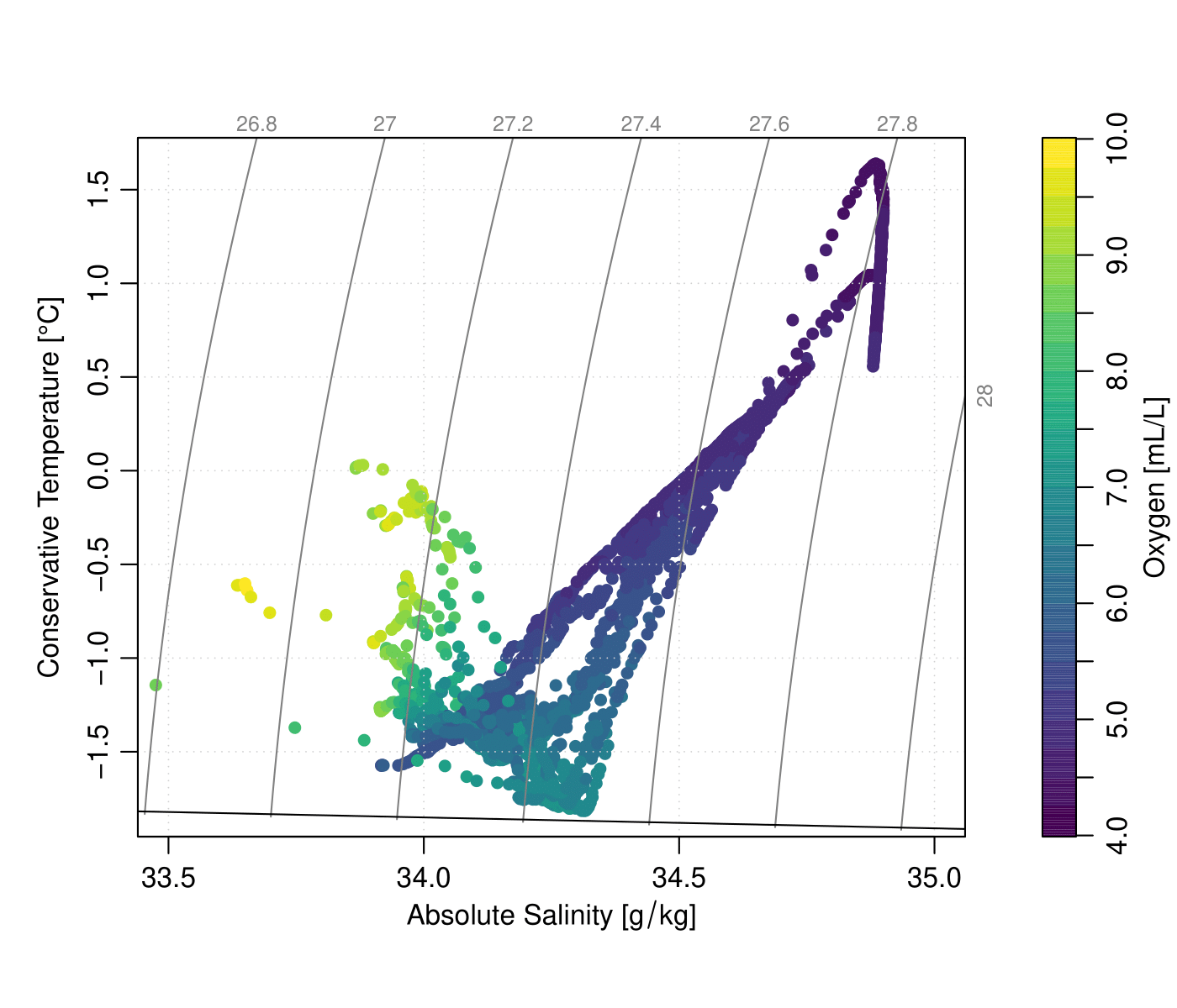

**Figure S1.** Temperature-Salinity plot for all ARTEMIS stations with DNA samples.

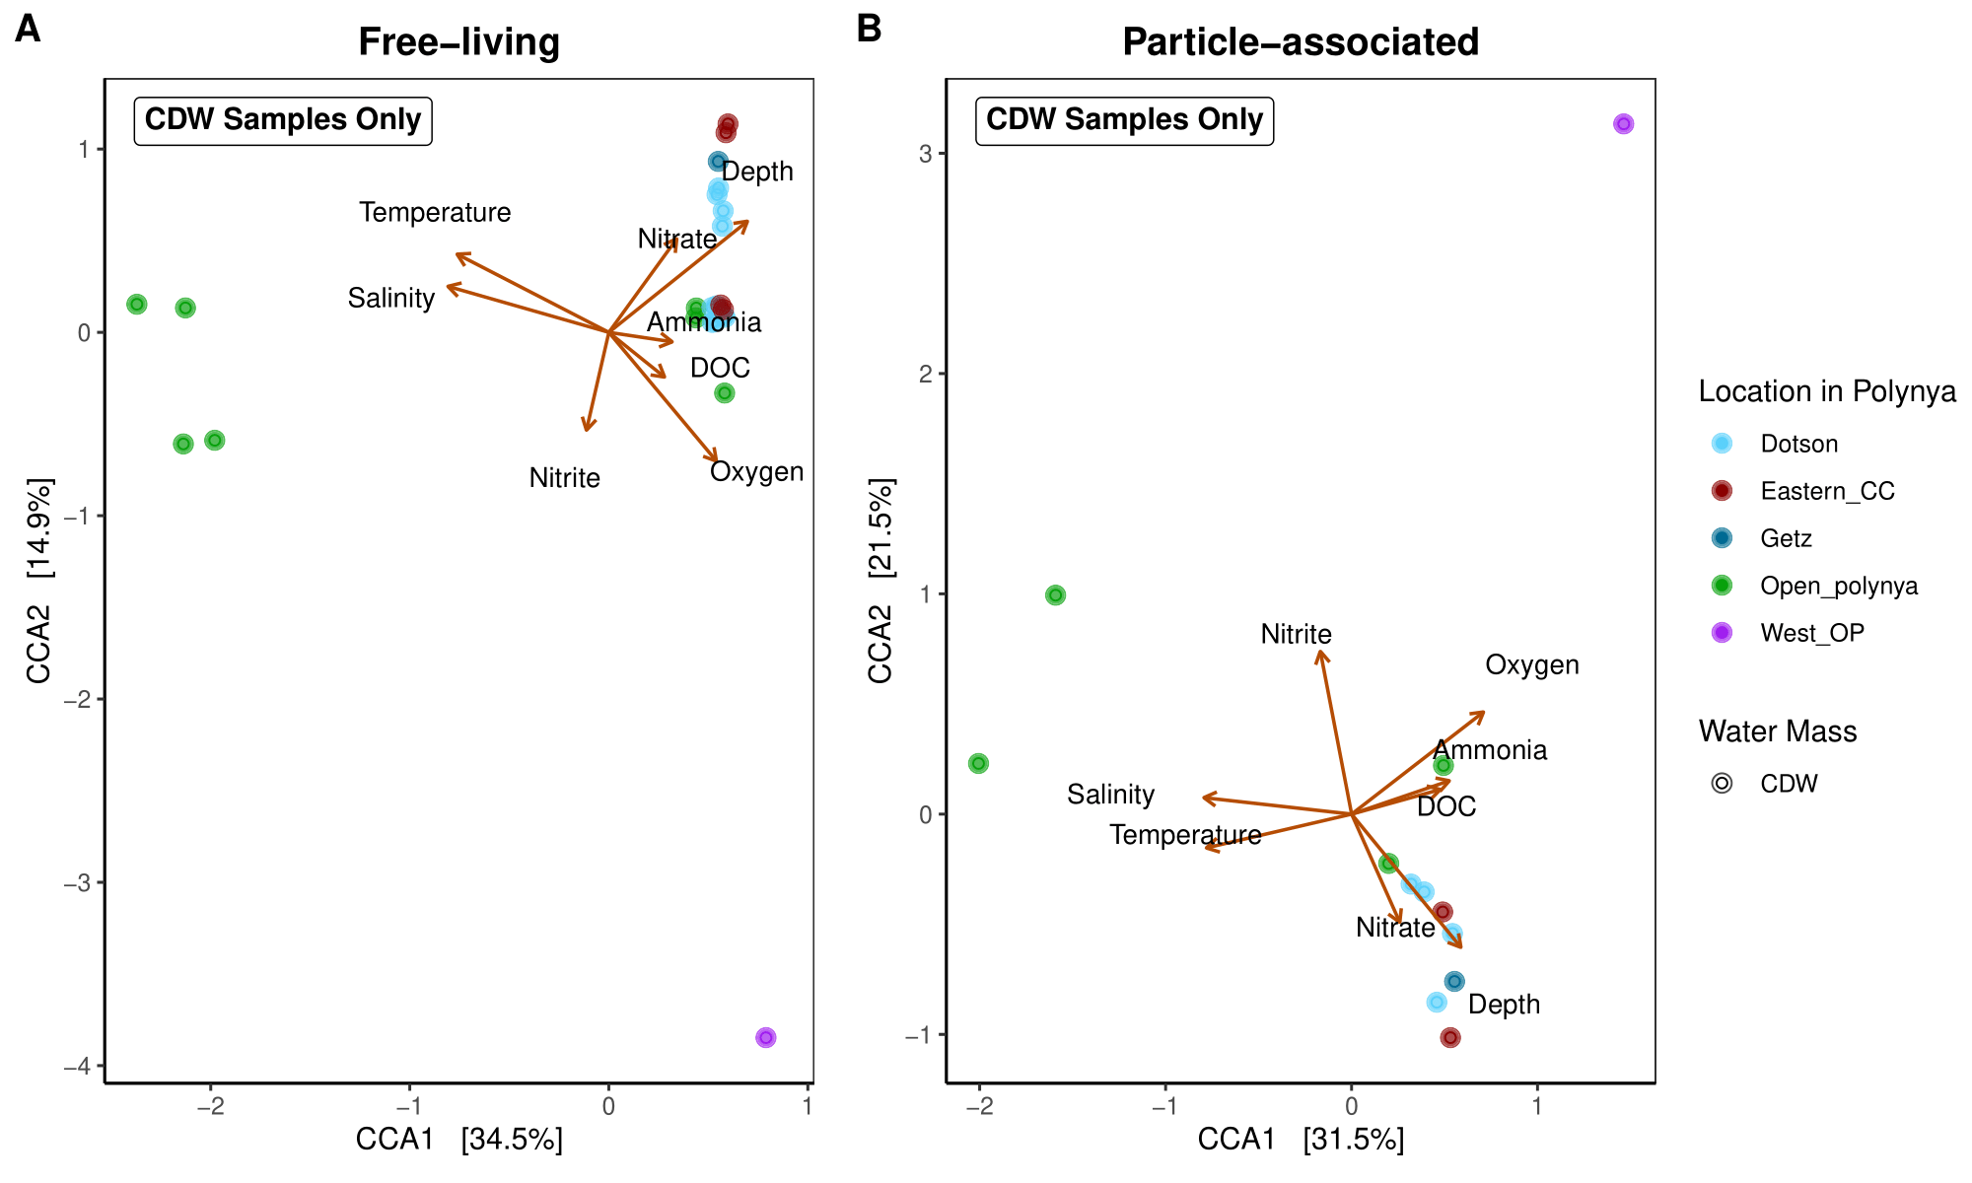

**Figure S2.** Canonical Correspondence Analysis (CCA) of free-living (**A**) and particle-associated (**B**) of samples that are characterized in CDW water mass, which are bottom water samples.

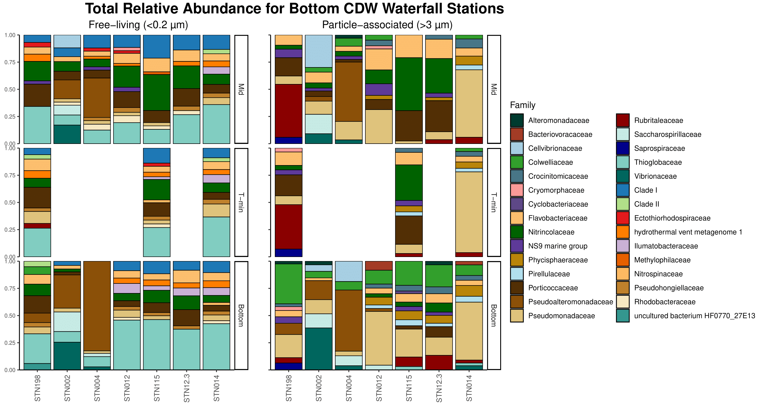

**Figure S3.** Relative abundance of stations coming from off the continental shelf at the family level. Free-living on left and particle-associated on the right.

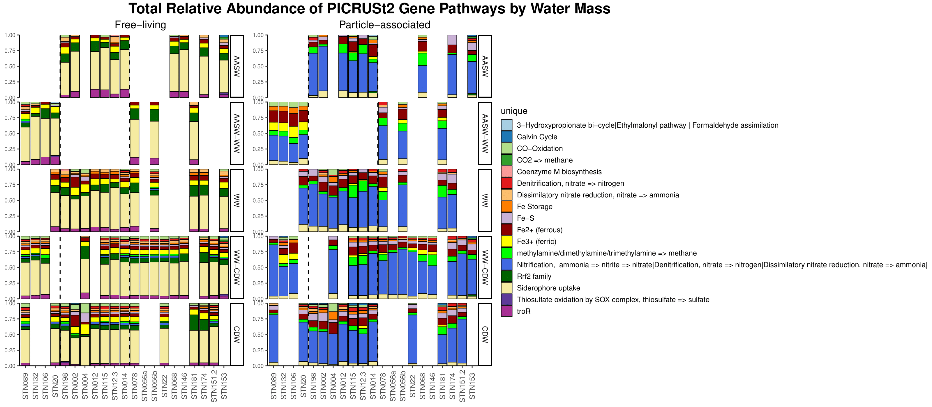

**Figure S4a**. Relative abundance of PICRUSt2 KO numbers by water mass and station. Free-living on left and particle-associated on the right.



**Figure S4b.** Legend that corresponds to **Figure S4a.**

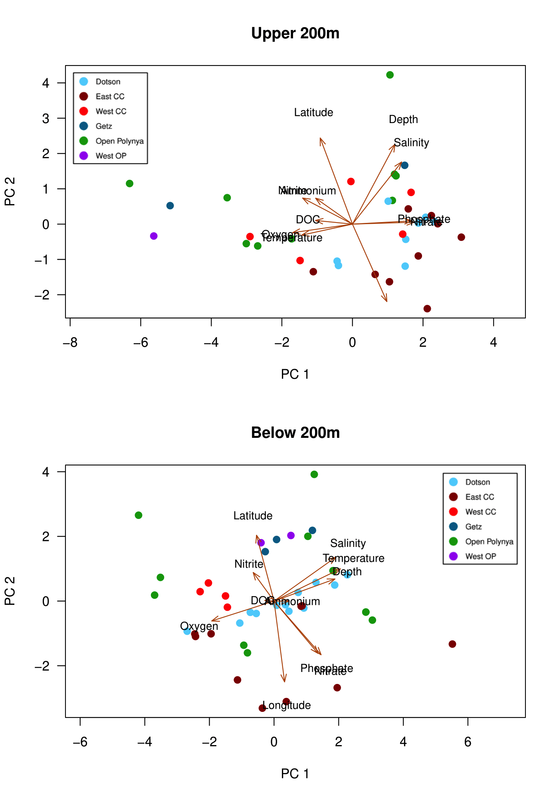

**Figure S5.** PCA of sample metadata by location in the ASP. Top PCA is surface-200m and bottom PCA is 200-bottom.

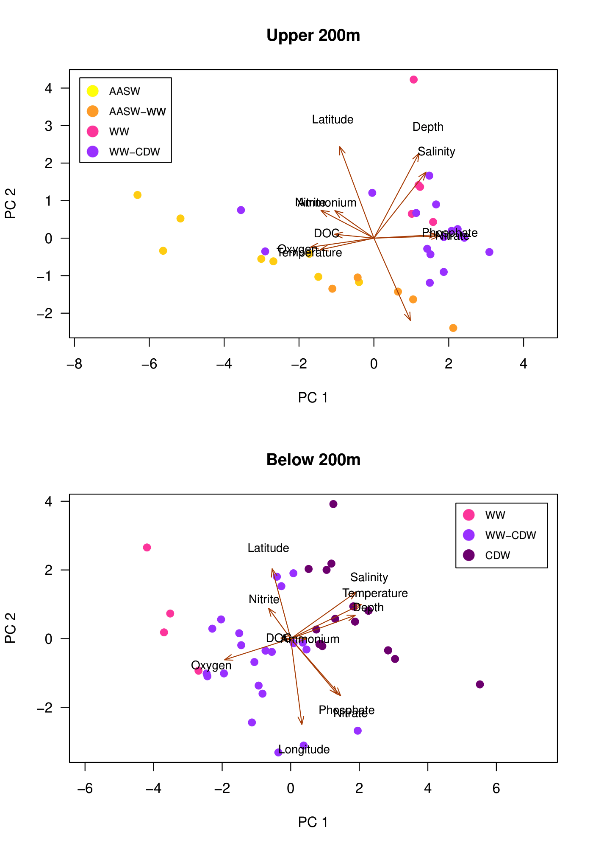

**Figure S6**. PCA of sample metadata by water mass in the ASP. Top PCA is surface-200m and bottom PCA is 200-bottom.

SUPPLEMENTARY TABLES

**Table S1.** Nutrient ranges for all stations combined.

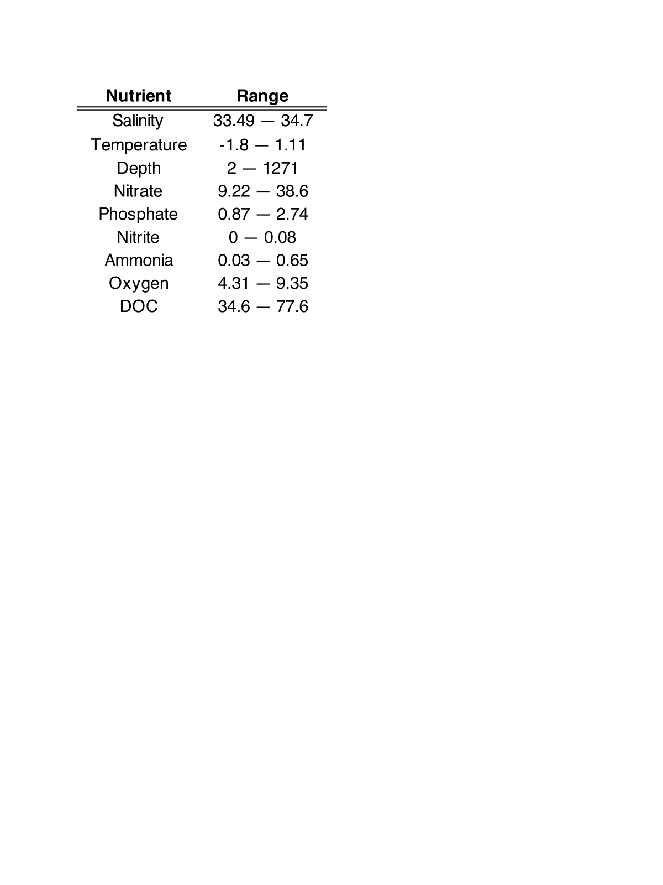

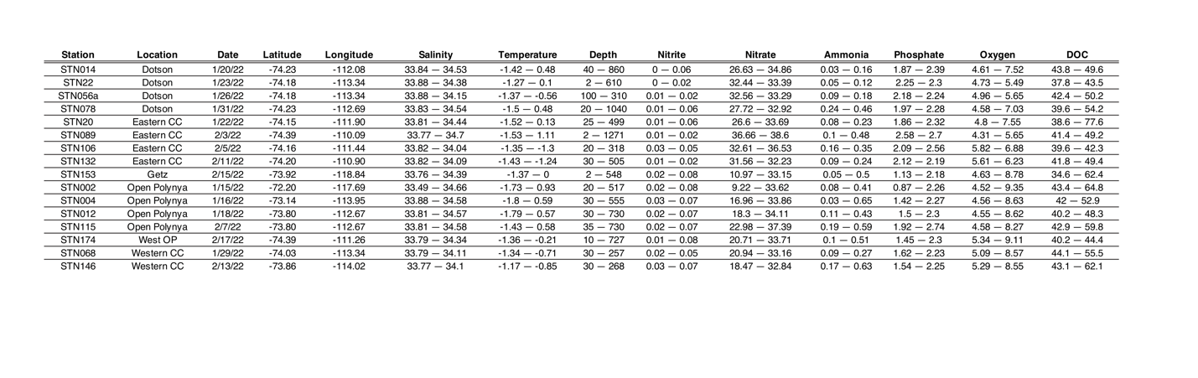

**Table S2.** Nutrient ranges per station.

**Table S3.** Indicator species for **free-living** communities based on location, separated into surface-200m (upper 200m) and 200-bottom (below 200m).

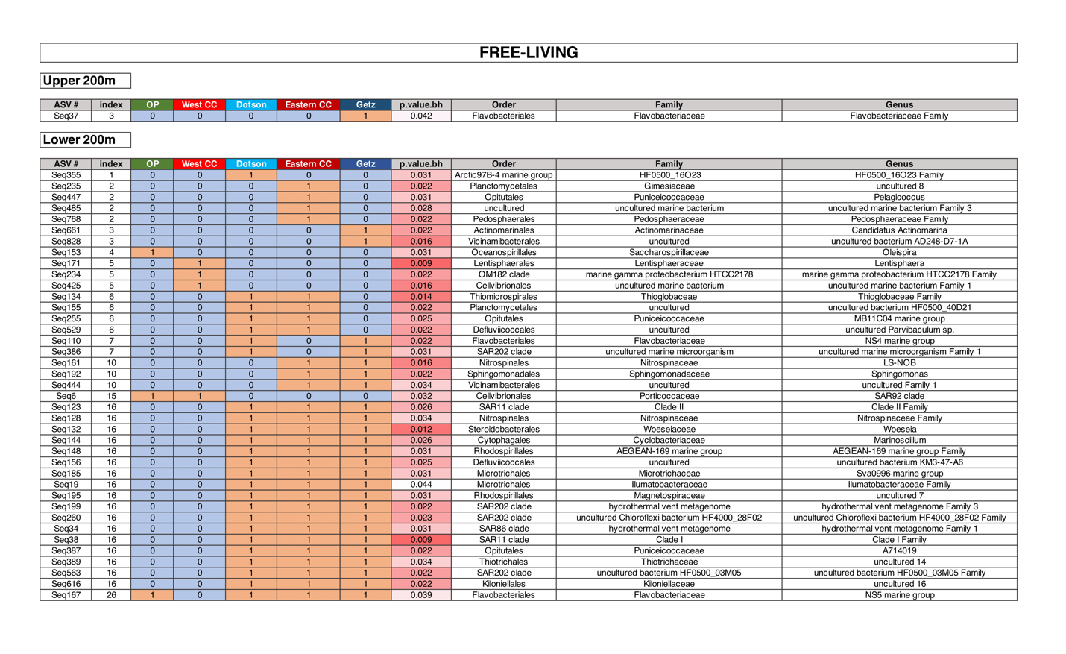

**Table S4.** Indicator species for **particle-associated** communities based on location, separated into surface-200m (upper 200m) and 200-bottom (below 200m). No significant taxa for upper 200m.

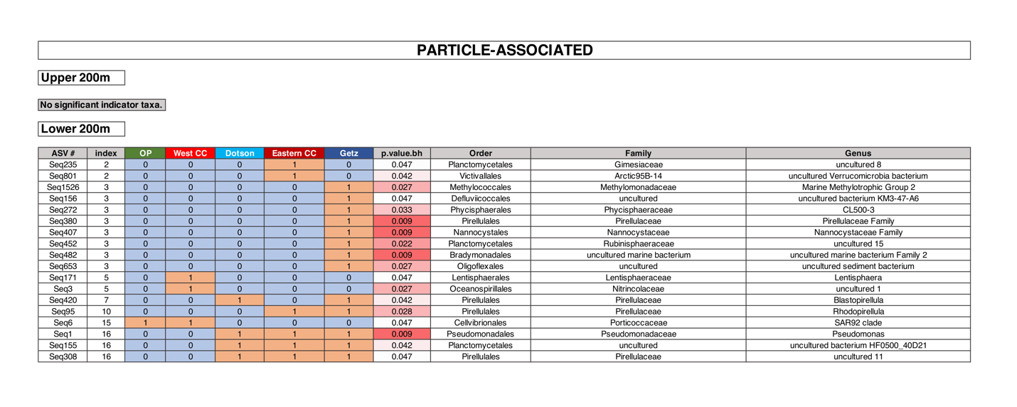

**Table S5.** Indicator species for **free-living** communities based on location for CDW samples ONLY.

